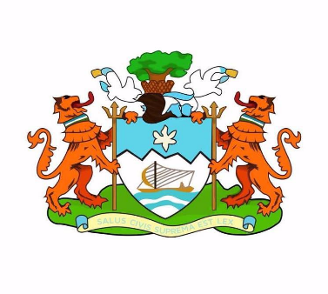[](https://nam03.safelinks.protection.outlook.com/?url=http://bit.ly/2EjFWBC&data=01|01|daniel.byrne@crs.org|a58834b50ff9465a743b08d7f04b2c44|b80c308cd08d4b07915c11a92d9cc6bd|0&sdata=SbBFGRf8p0VIWkb14ySNePId7k3T/WLfgG9wEd0msgI%3D&reserved=0)

**Press Release:**

**Launch of the #EUStandsWithSalone - Supporting Freetonians confront COVID-19**

There are over 400 confirmed cases of COVID-19 in Sierra Leone, with about 80 % of those in the current epicenter of Freetown. Freetown indeed faces an acute threat due to the density of its population. Through the generous financial support from the European Union, a consortium of CSOs led by Catholic Relief Services (CRS) - in coordination with the Freetown City Council (FCC) - on 23 April 2020 started the **“#EUStandsWithSalone - Supporting Freetonians confront COVID-19’’** action.

This action is designed to support the Government’s response and the Freetown COVID-19 Preparedness and Response Plan managed by the FCC. The 12-month action is valued at 2.23 million Euros (23.6 trillion SLL).

The activities of this action seek to help Freetown residents effectively respond to COVID-19 and to meet the needs of the most vulnerable segments in society: the estimated 350,000 residents of the 68 informal urban settlements. The action will ensure they are informed about updates and best practices related to COVID-19 and that they benefit from sustainable water access, sanitation services, dignified quarantine and improved pediatric and maternal health as well as services for women and children who are victims of domestic and sexual abuse.

More specifically, the action will contribute to the upgrading of health facilities and the creation of two new basic emergency obstetric and newborn care facilities to ensure pregnant and lactating mothers and their babies receive dedicated and adequate health care even at most difficult times. It will equip and manage three new isolation & containment centers and support effective community level contact tracing for confirmed cases, notably in the slums.

To contain the spread of the virus, the action will support 1-year provision of water and sanitation, hand-cleaning and personal protective equipment (masks, gloves) to the city public health units (PHU), isolation centers and public markets. It will ensure that the 42 public markets of Freetown are regularly disinfected and adopt physical distancing and emergency protocols. Face masks are being provided to all the municipal market vendors and their children. By joining the #MaskUpFreetown and #MaskUpSierraLeone campaigns by Madam Wokie and Izelia Fashion Houses, the action contributes to the production of masks and their distribution to the most vulnerable.

In view of further supporting public health, food security and resilience of Freetonians, the action will also contribute to drainage cleaning and flood mitigation measures, as well as urban farming pilots.

The action will be managed by the consortium manager Catholic Relief Services, and implemented under the coordination of the Freetown City Council by the local organizations Caritas Freetown (CF), Federation of Rural and Urban Poor/ Centre of Dialogue on Human Settlement and Poverty Alleviation (FEDURP/ CODOHSAPA), the Sierra Leone Red Cross (SLRC) and the Aberdeen Women’s Center (AWC).

All activities will coordinate with relevant ministries and development agencies and ensure strict adherence with the Ministry of Health and Sanitation (MOHS) directives and recommendations.

For further information:

European Union

Name: N'Fa Alie Koroma

Designation: Press & Information Officer

Contact: +232 76741418

Freetown City Council

Name: Koma Hassan

Designation: IEC Officer

Contact: +232 76 404979

Catholic Relief Services:

Name: Dennis Momoh

Designation: Partnerships Advisor

Contact: +232 76 541545